October 30, 2017

Joseph Goergen, Coordinator
Science Based Conservation Programs and Research
SCIF Conservation Department
501 2nd St NE
Washington, DC 20002

Re: A genomic toolbox to enhance management of extant Canada lynx and bobcat populations

Dear Mr. Goergen,

We are writing to show our support for PI Steven DeStefano’s proposed project, “A genomic toolbox to enhance management of extant Canada lynx and bobcat populations.” We believe Dr. DeStefano’s proposed project will greatly benefit our agency and further the efforts of those working to conserve and manage Canada lynx and bobcat populations. We have worked closely with Dr. DeStefano, co-PI Organ, co-PI Johnson, and their PhD student, Ms. Lama, over the last several years.

We have been biologists for the State of Maine Department of Inland Fisheries and Wildlife for a combined 17 years with the responsibility of managing and conserving Canada lynx and bobcats. Our mission, to protect and enhance the state’s wildlife populations while providing sustainable use of resources, has been supported by Dr. John Organ through multiple research projects, such as a 12-year telemetry study of Canada lynx in northern Maine. Through this project, we were introduced to Dr. Warren Johnson, who developed collection protocols for long-term DNA storage from captured lynx.

The status of Canada lynx in Maine had been a matter of speculation, resultant in lynx being listed as a single DPS under the Endangered Species Act in 2000. As a result, several research projects were initiated to assess historic and current status of lynx in Maine. However, these studies have not addressed uncertainty over historic population levels, or future persistence, and population viability. Conservation genetics could help tackle these knowledge gaps but, to date, have largely been inconclusive due to the limited number of available lynx-specific markers. The genomic approaches detailed in Dr. DeStefano’s proposal will produce powerful tools for estimating key parameters in wildlife management, such as effective population size and the ability to test hypotheses regarding demography, connectivity, and hybridization.

Bobcats in Maine are taken by both trapping and hunting, and the State has historically managed the population by adjusting harvest length, timing, intensity, and defining legal methods of take. We recently instituted mandatory tooth and tissue submissions from bobcat taken in the 2016 hunting season, resulting in a collection of 33 tissue samples available for analysis. A reliable estimate of population abundance would be the most useful metric resultant of this proposal for the purposes of long-term monitoring. Additional insights into the status of our bobcat population would facilitate effective communication about management decisions, particularly relative to bobcat harvest with stakeholders and the general public.

At the most fundamental level, this research will provide resources in support of science-based management for bobcat and lynx in Maine. We eagerly anticipate continued collaboration on this project.

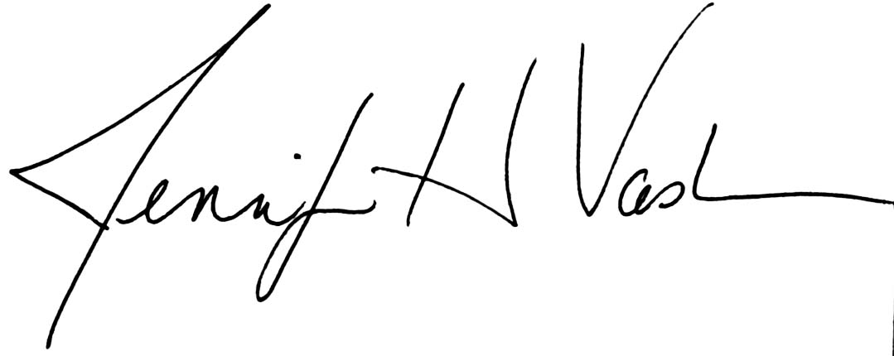

Sincerely,

Jennifer Vashon
Lynx Biologist
Maine Department of Inland Fisheries and Wildlife

Cory Mosby
Furbearer Biologist
Maine Department of Inland Fisheries and Wildlife

